Foundation Year Project Report

Computer Science

Group K

Created by:

Salman Ashraf

Engin Gedik

Jamie Li

Aadil Sarwar

Martine Shams

Contents Page:

Cover – Page 1

Contents – Page 2

Website Brief – Page 3

Website - Design Aspect– Page 4

Website – Technical Aspect

Conclusion

1 Website Brief

# Introduction

This website’s purpose is to provide key information that we feel is essential to know before starting a Computer Science Foundation Year in the University of Manchester, and the relevant experiences each of the group members has had. We hope that this can serve as a guide to help future and current students with their experiences and make the most of their time at Manchester and their course.

# Influence of the website on the design

The website’s purpose is to provide information on the key aspects of life at the University of Manchester as a Foundation Year student. This allowed for the website to be divided into multiple segments

* Introduction – The main landing page that doubles as a context
* City of Manchester – Information about the heritage of the city
* University of Manchester – The facilities that are available and career opportunities
* Foundation Year – Summary of course content and progression
* Student Life – The life as a student and what you can do outside of lectures
* About Us – Our short biographies

This allowed each tab to be designed around it’s respective topic. We delegated the topics to each group member based on their own experiences in said topic.

# Influence of the website on technologies used

The website was created using HTML5, and CSS3.

* This was only influenced by the task, which was to create a website

The code editor of choice for the entire group was Visual Studio Code (VS Code).

* It was the code editor the group had most familiarity with, alongside it being easy to integrate with GitHub
* Extensions from the VS Code marketplace were employed as well, including but not limited to:
  + Prettier – Prettier
  + vscode-pdf – tomoki 1207
  + Live Server – Ritwick Dey
  + Image Preview – Kiss Tamas
  + Color Highlight – Sergii Naumov
  + Auto Rename Tag – Jun Han

Version control, backing up and synchronising was done by integrating GitHub to VS Code.

* GitHub was selected for this purpose due to one of the group members being comfortable using it, which allowed for the group’s work to be always synchronised and available to all members without clashing documents.

In terms of the influence of the website on technologies used, there is no significant influence, but the technologies were selected based on the group’s familiarity with them, and if they made it easier to create the website.

As a side note, whilst creating the report, PicPick was a very beneficial tool to use, as it allowed for the capture of rolling screenshots, which allowed entire pages to be taken as a screenshot and preserve the appearance of the site.

1. Website – Design Aspect

# The structure of the website

There are 4 distinct styles that can be found within the website. The “Home” page has its own unique style that is dedicated to help with initial navigation. The “Manchester”, “UOM” and “Student Life” are styled to allow multiple images with text to help readers understand the foundation year experience. “FY” is more information heavy than the other categories due to the extensive nature of the course. The “About Us” section is designed to allow insight into the team members, hence why there is more emphasis placed on the balance between images and text.

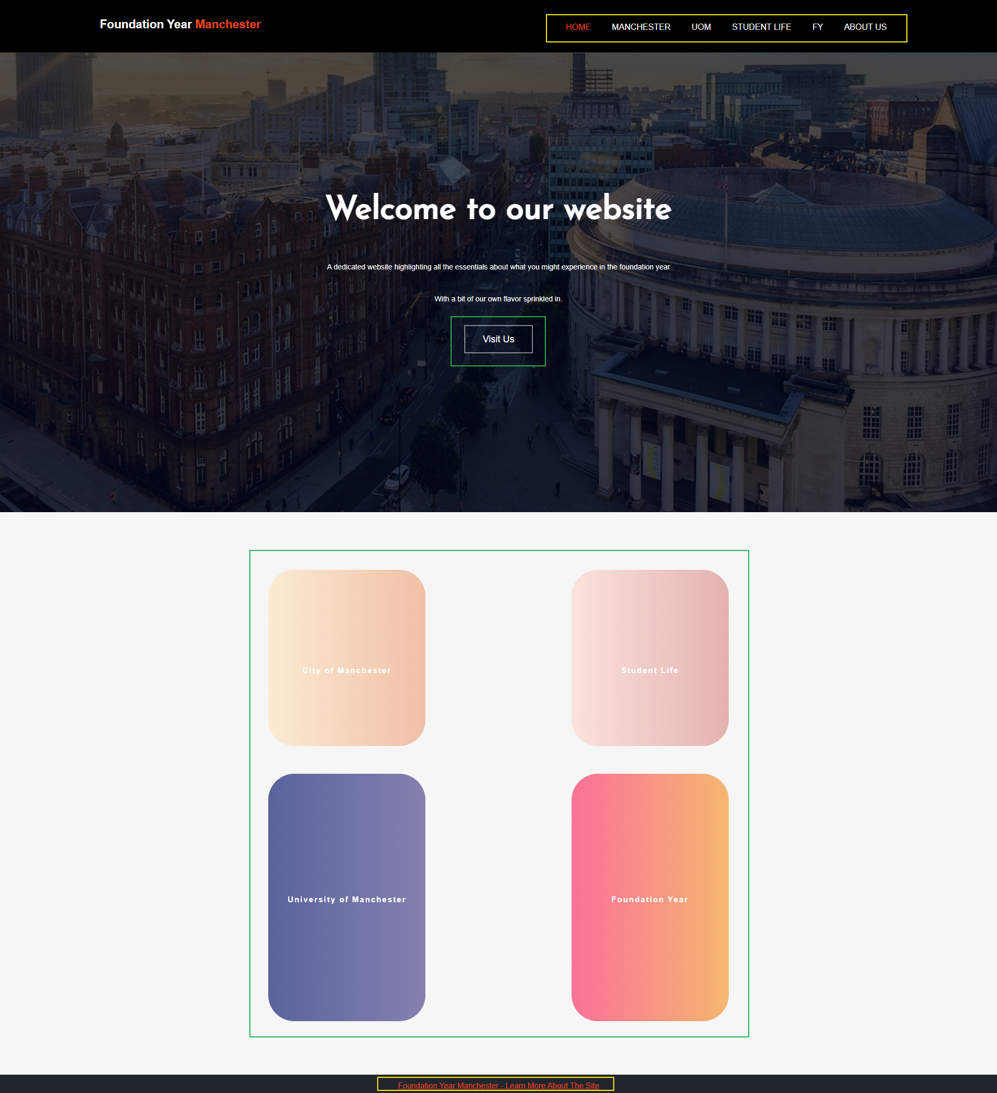

Figure : main landing page

Figure 1’s design is based around helping navigation and providing easy access to the different areas within the website. The distinct lack of images and text is to contain the attention of viewers on either the top navigation bar or the bubbles to use as navigation.

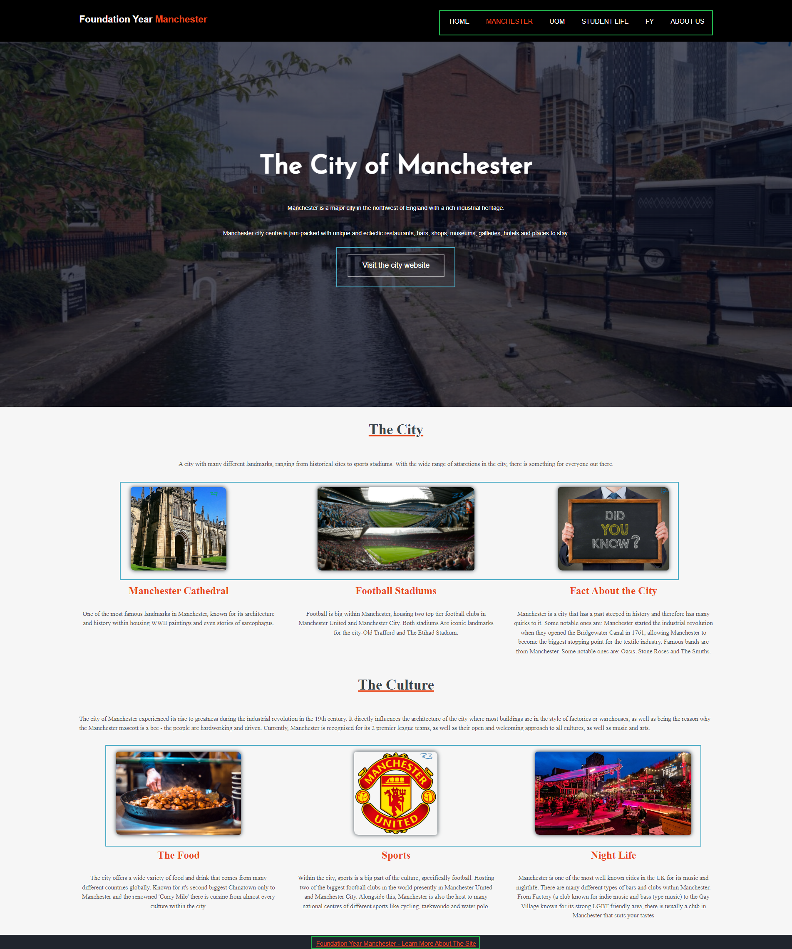s

Figure : Manchester section of the website with highlights

The design of the Manchester section of the site is designed to provide concise information regarding its respective topics.

The page is divided into 3 sections, the main loading page, with the “The City of Manchester” text and banner, the first information segment – “The City” and the second information segment – “The Culture”.

These contain subtitles and subtexts to engage the readers and provide an overview into the respective sections of Manchester.

Images contained within the blue boxes in Figure 2 are used to navigate into external sites that will provide information regarding the text it is associated with.

Like the other pages, the top navigation bar and footer, boxed in green, can be used to access the other sections and the GitHub repository.

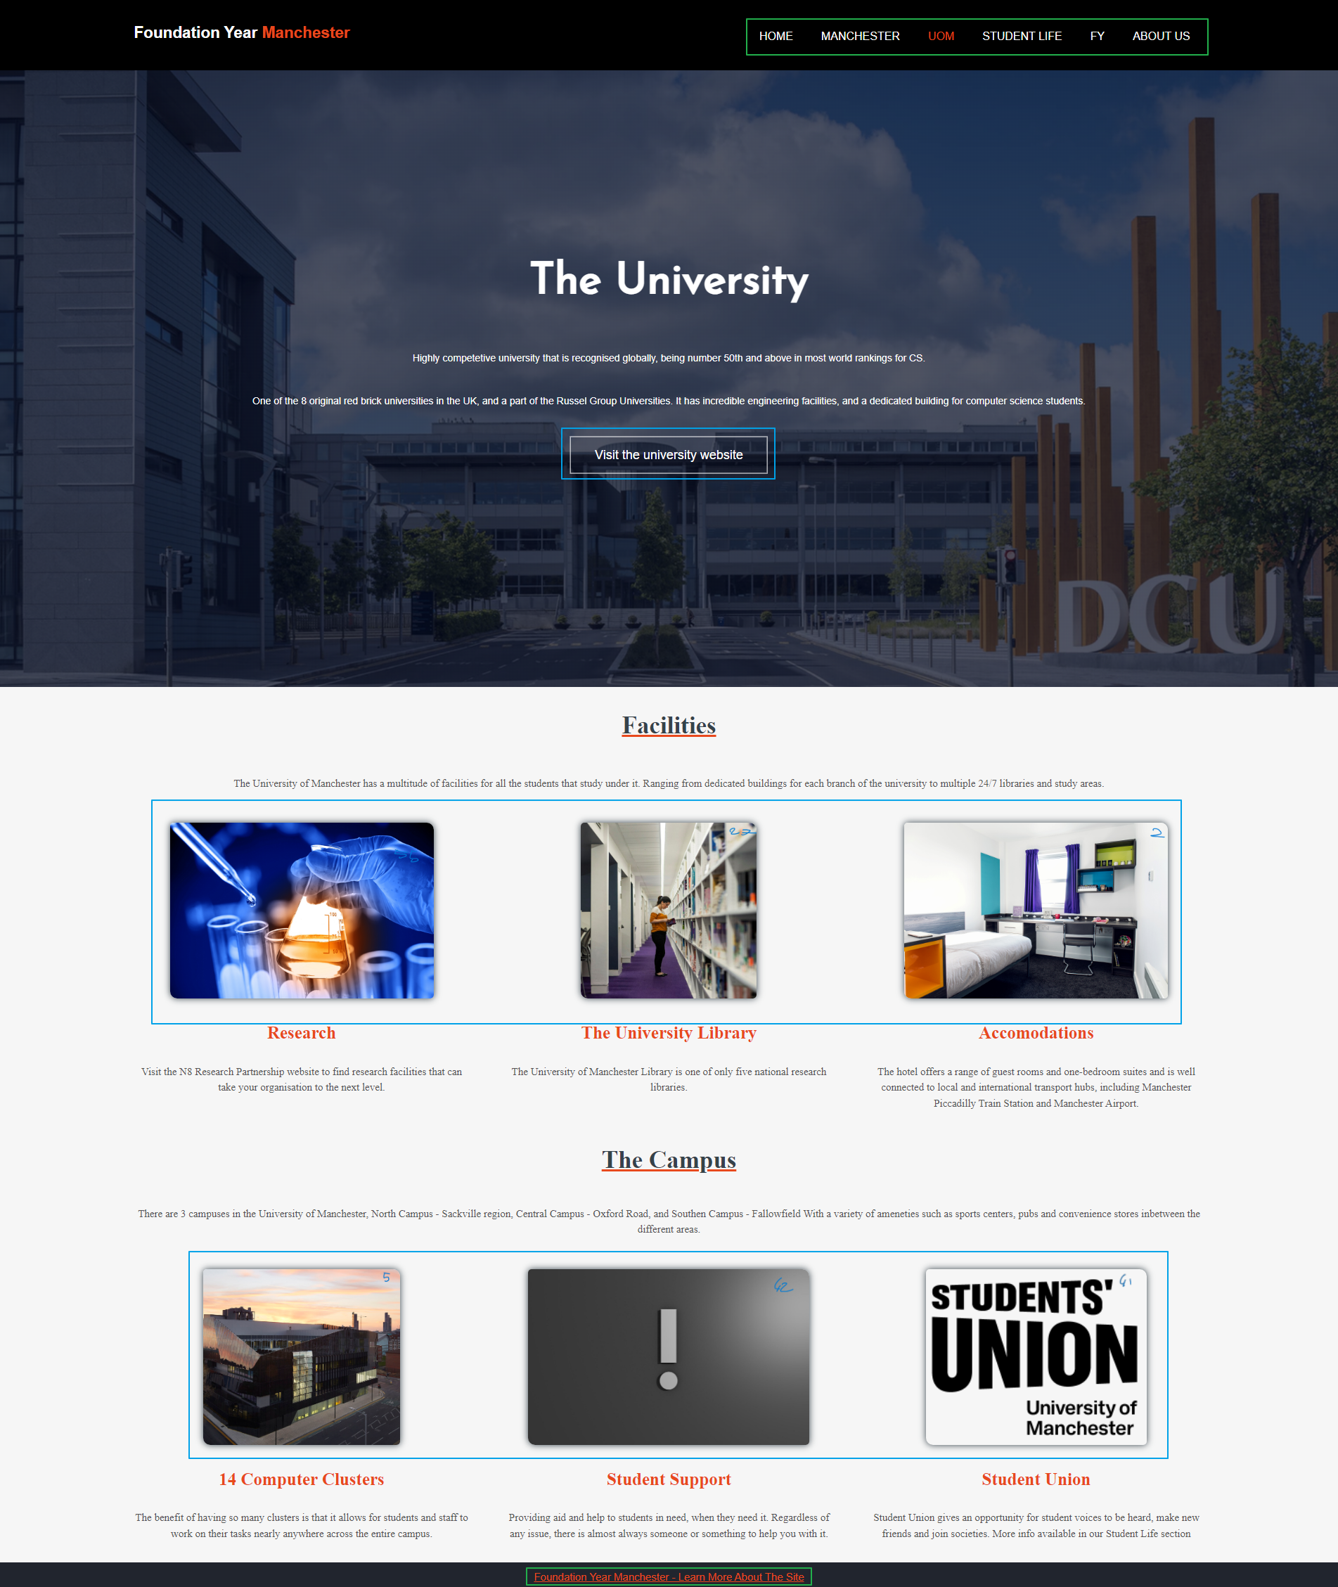

Figure : UoM section of the site with boxes to highlight sections

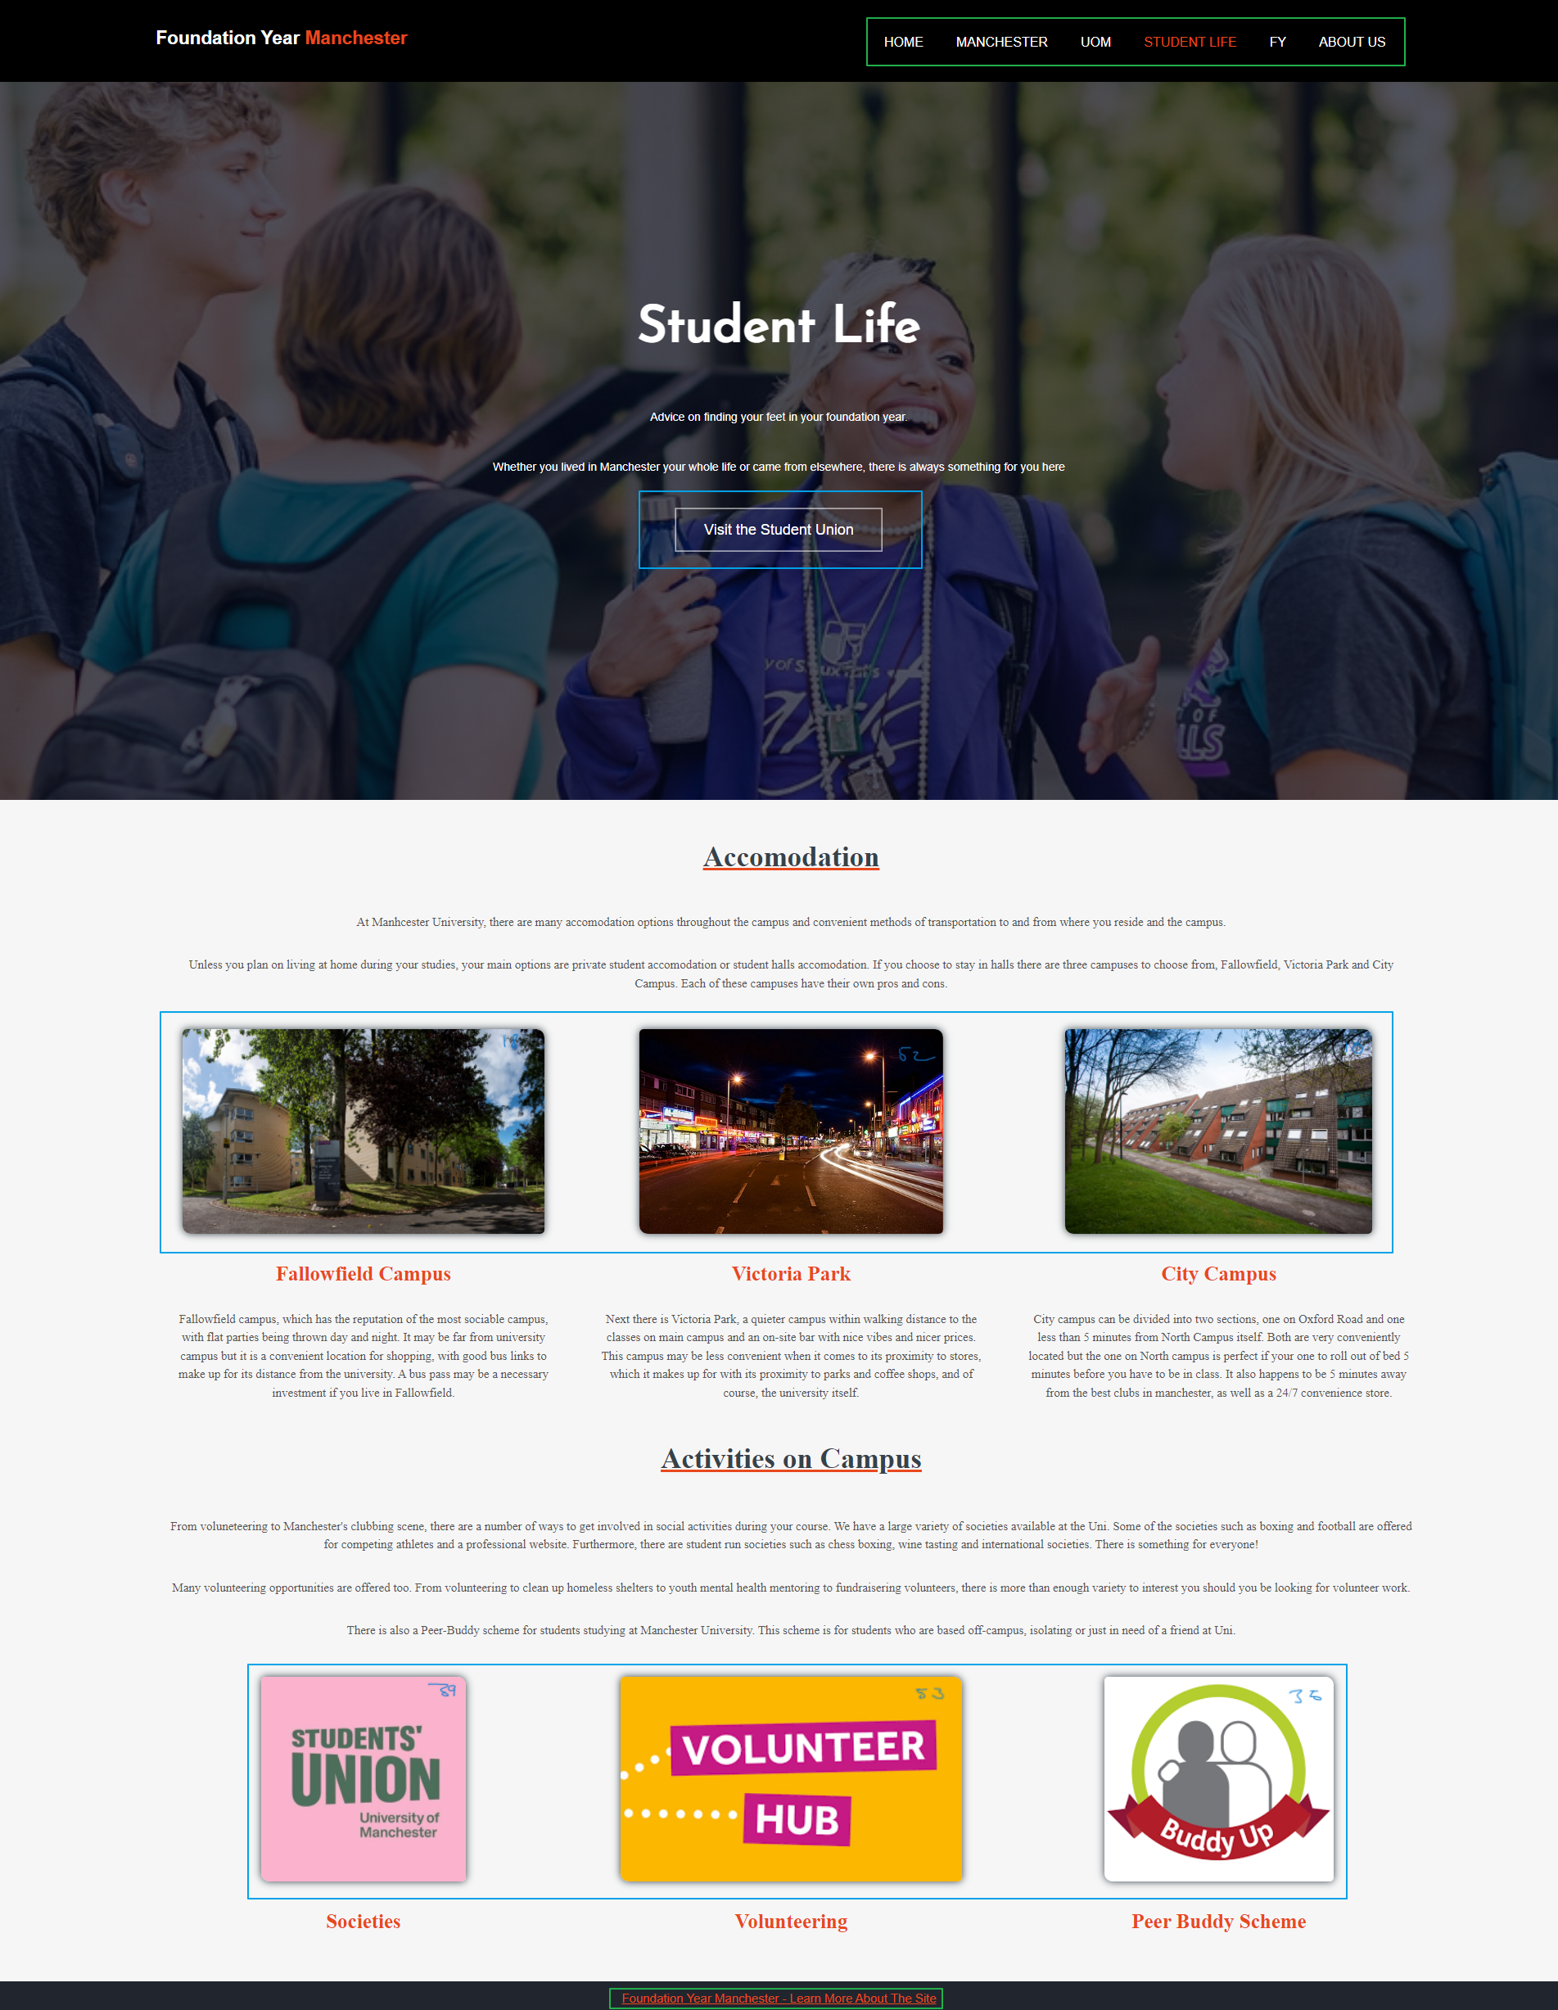

Figure : student life section with boxes to highlight different segments

Likewise to Figure 2, Figure 3 and Figure 4 have a layout that is split into 3 categories, title and banner, 1 segment of information followed by another segment. The blue boxes that encapsulate images and a button is used for external navigation, and the items encapsulated by the green box is used for internal and GitHub navigation.

# Navigation

## Navigation From Landing Page

Figure 1 contains 2 forms of navigation:

1. The yellow box that encapsulates the top navigation bar and the footer.
   * The navigation bar and footer are present in all the tabs. This is the main method of navigation between the different sections. The navigation bars are designed to lead into other tabs within the website, and the footer is linked to the GitHub repository the site was developed in.
2. The green box that encapsulates the [Visit Us] button and the 4 bubbles.

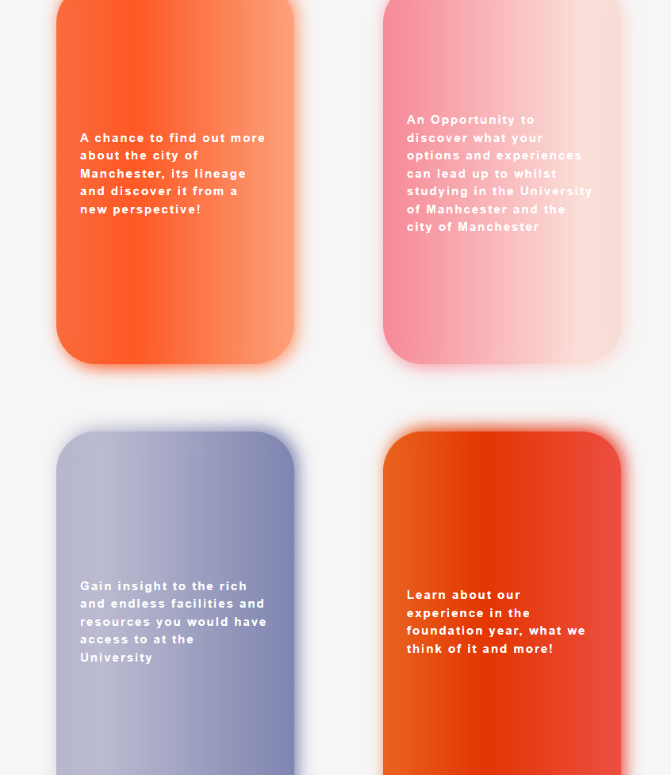

Figure : landing page bubbles under forced hover state

* + Similarly, to the top navigation bar, these buttons are designed to direct users into the different sections within the website. As seen in Figure 5, the bubbles provide basic information about the relevant section when hovered over.

## The top navigation bar (and footer)

The navigation from all the different pages within the website are via the same method. The top navigation bar that is boxed in green for Figure 2, Figure 3, Figure 4 and in yellow for Figure 1. The name of the tab that is currently being viewed will turn orange to indicate which one is being used.

The footer is also present at the bottom of each page, allowing access to the repository constantly throughout the site.

## Navigation to External Sites

An example of an image, button and link that is used to navigate on to external sites:

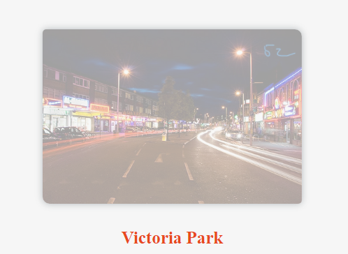

Figure : image hovering effect for external navigation

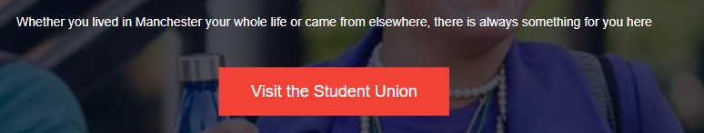

Figure : external navigation via button

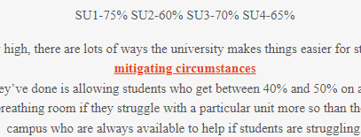

Figure : Link based external navigation example

The images that have an opaque white layer over them when hovering over are anchors that take users to external sites, as seen in Figure 6. This is done so that users can realise a significant change in style will engage them and incentivise them clicking on the image, to be redirected.

The button changing styles, Figure 7, and the links getting bold, Figure 8 is done for the same reason, to cause a change in state of the item, and to engage the user to click on it to be redirected.

# Visuals and information

## Visuals used

As mentioned in 2.2.3, images are used as a source of navigation, as well as providing basic visual information to users. The benefit of this approach is that it allows the site to convey information and give users an opportunity to explore topic in more depth if they wish to by engage with the button, as seen in Figure 6.

Some images retain their standard image properties, of just being an image. They do not contain links or animations and are there for the aesthetic and providing information via just the image. An example of this would be any of the banners that can be found in all the pages, behind the title and low-opacity black tint.

Other visuals used would include animations in the main landing page, on the hover effect. Figure 5’s bubbles have a gradient cycling and an under-glow effect added to them. There is no functional reason to it, but rather a visual stimulus

## Information used

The way the information needed and would be used was partially decided by the objectives and tasks for this project. The other major influence was what information students wished they had. These 2 factors directly influenced how the information was gathered and got implemented.

The method of getting the content was creating key headings, which branched off into subheadings,

i.e. Student Life 🡪 Accommodation, Clubbing, Societies

Using the subheadings, they became the topics to write about in their respective pages.

The content was gathered by:

* The experience of each group member – as to make it more authentic and genuine from a fellow student viewpoint
* The university website – as the information would be directly from the source and accurate
* Online forums and sites – to provide insight into the experiences and knowledge of others

Having these 3 gathering methods and using them in tandem with the branch layout, thorough and accurate information was put together to be placed on the website for use.

1. Website – Technical Aspect

# How does it work

The site works by using HTML5 code for the main content of the site, and CSS3 to influence the design and aesthetics.

## Landing page

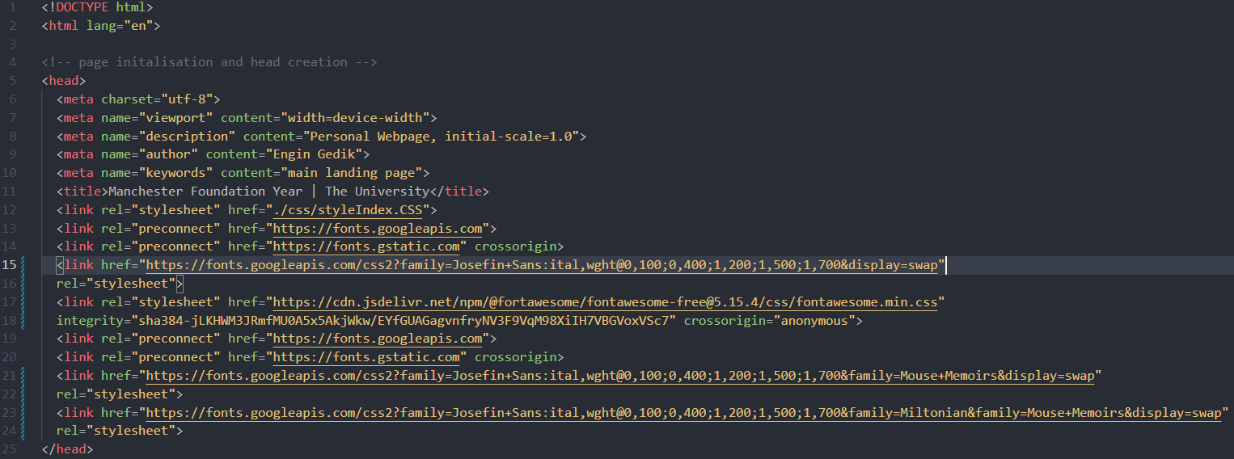

Figure : landing page initialisation html

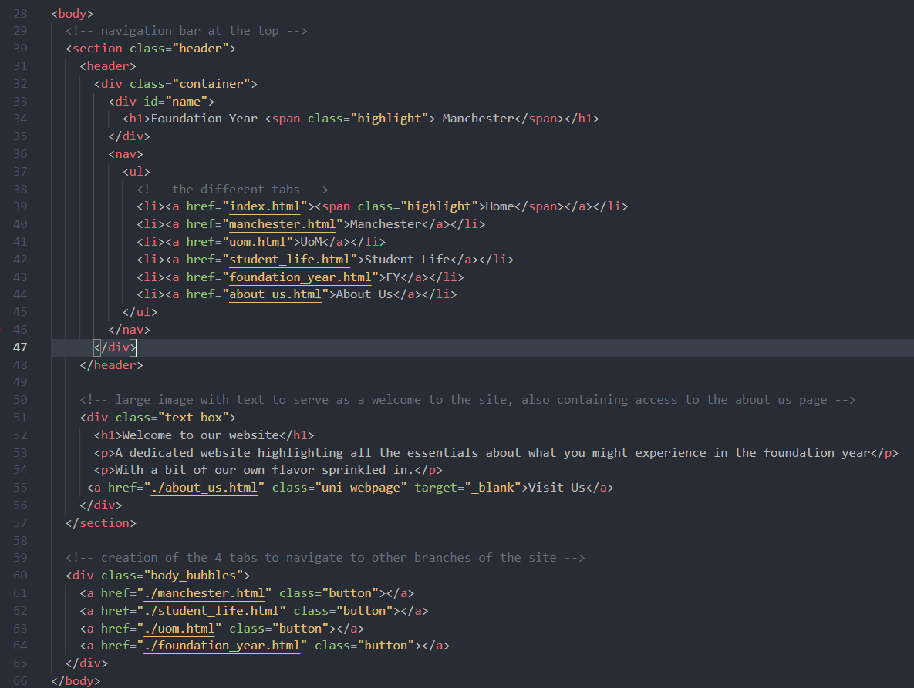

Figure : landing page body html

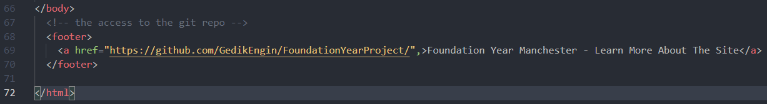

Figure : landing page footer html

Figure 9 initialises the webpage, links it to the correct CSS file and imports the fonts that are/were being used.

Figure 10 lines 28 to 48 create the top navigation bar and establish the title of the webpage. Lines 51 to 57 are responsible for creating the container that the banner and banner text are housed in. Lines 60 to 65 are responsible for the 4 bubbles that aid the navigation of the main web page.

Figure 11 contains the code for the footer that has an anchor tag that is responsible for leading users to the GitHub repository when clicked on.

## Manchester, UoM, Student life, FY

The four middle tabs are built using similar layout.

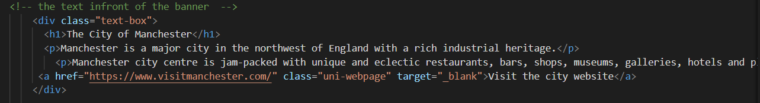

Figure : MANCHESTER PAGE MAIN IMAGE HTML

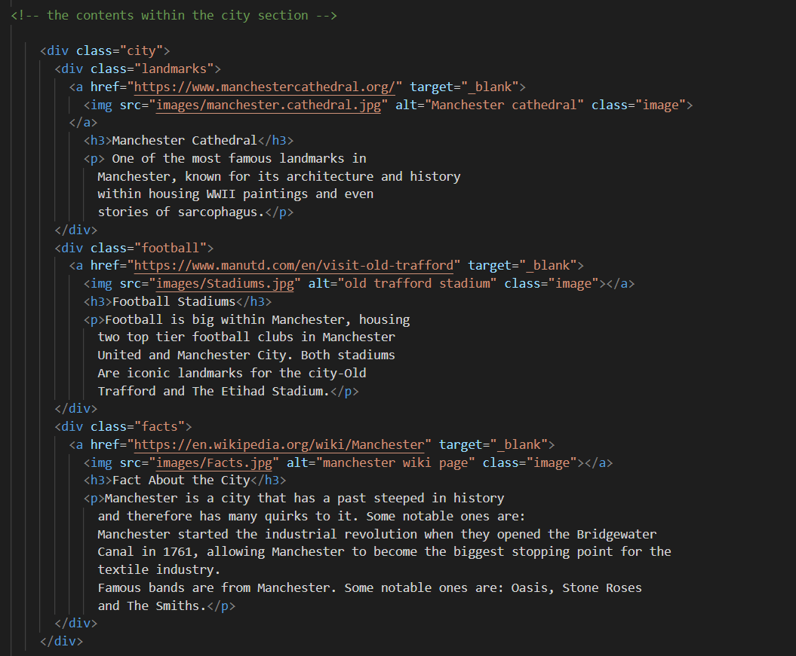

Figure :MANCHESTER PAGE BOXES HTML

As shown on the website, these four tabs use similar HTML design. This was decided as a group to keep the website tidy. The section title, fonts and hovers were decided independently.

All the images used are hyperlinks to navigate to respective webpages to find out more about the images and information below it.

The footer is the same for all tabs and can be seen in FIGURE 11.

## About Us

This is one the unique section on the website. The main background image is just as FIGURE 12.

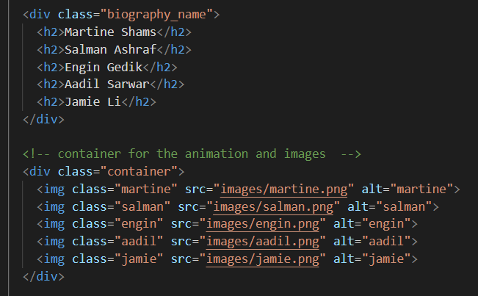

Figure : Biography section from 'about us' page

The highlight of this page is the introduction of all the member of the group. The class ‘container’ was used to add hover effect and animation.

# Tech used during creation

## Creation process

The structure of the website was initially created on Trello. This allowed for deadlines to be set, labels to be used to classify cards and highlight their priority. It also allowed for the division of sections and planning out of the content and what would be contained.

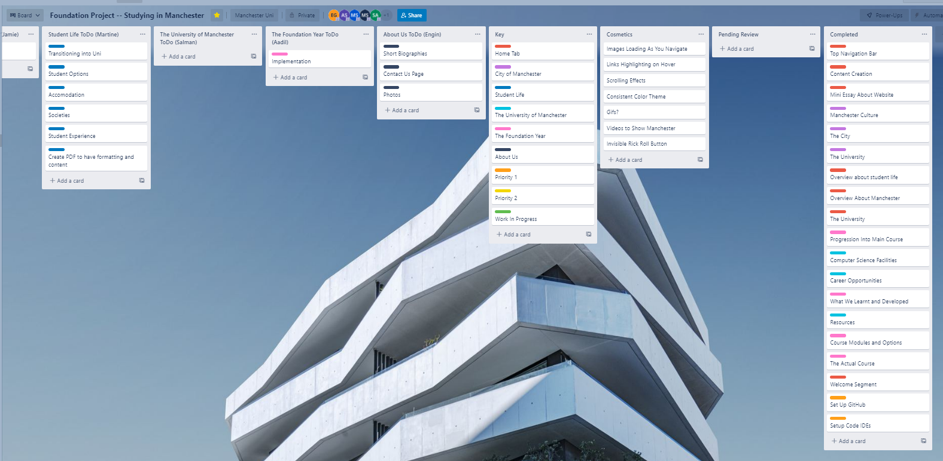

Figure : screenshot of the trello board midway through development

Once the basics of Trello was established, GitHub and Visual Studio Code was introduced into the group and project environment.

Using GitHub allowed for each member to work on the project at their own time and pace, which was important as a significant amount of the project was done over the easter break.

Visual Studio Code was used as that was the code editor that most of the group were familiar with, as well as having support for multiple extensions that were assistive in the creation of the site as well as GitHub.

These extensions include but not limited to:

* Prettier – Prettier
  + Modifies the visual appearance of the code to make it easier to understand and keep track of.
* vscode-pdf – tomoki 1207
  + Allows for the viewing of PDF files within the code editor, it is a quality-of-life measure that was beneficial when referring back to documents and plans previously made by the group and/or staff members
* Live Server – Ritwick Dey
  + Allowed for the changes made to the code to be viewed immediately
* Image Preview – Kiss Tamas
  + Allows for the images to be loaded in a mini fashion in the gutter, which helps as a guide to what image is being worked with
* Color Highlight – Sergii Naumov
  + A quality-of-life measure that was used in the CSS side of the project, helped in picking custom colours and viewing them without having to refresh the side
* Auto Rename Tag – Jun Han
  + An extension that changed the closing tag to match the opening tag and vice versa, which was beneficial when changing the structure of the code

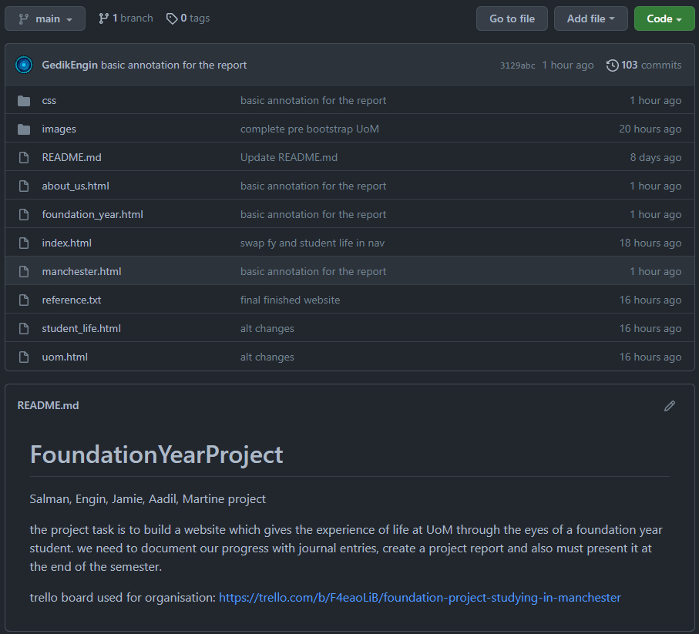

Figure : github repository

## Programming

The programming was done with HTML5 and CSS3, this was influenced solely by the task that was assigned and the objective of the site, to create a website detailing the Manchester Computer Science Foundation Year

# Creation process

## Pre-creation of site

The initial steps involved using Trello and pen and paper to create the rough plan of the site. Once the basic sections (Landing Page, Manchester, Student Life, UoM, FY, about us) were established, the subcategories within them were getting populated with relevant information.

The next steps were to install VS Code onto the personal machines of each group member, download the basic extensions and set up GitHub. GitHub was then tested and used with a series of test commits and initial commits to get familiar with the operations.

## Early creation stages

The early stages of the site included importing a website from one of the group members. The website was then heavily modified and purged of any old content and repurposed under the sections that it was meant to contain. The sections were divided between the group members based on their expertise and choice. After the delegation of tasks, the research stage took place, so that it would be easier to implement each section into the site as there would be a blueprint to follow.

The navigation bar, banner and footer was included in all pages as a compulsory style, and a colour theme of orange-white-black was established.

## Main creation phase

During the main creation phase, there was a significant number of stylistic changes taking place. Much of the content remained the same, however the styling and presentation underwent heavy changes multiple times. Each group member worked on their own section, either by experimenting with the built in features or using online sources and modifying them to suit the specific style that they wanted to achieve.

## Final stages

During the final stages, all the styles were brought into a more streamlined version, where the font and tag styles were the same and uniform, 3/6 web pages had a near identical layout due to the information and layout they contained. Animations and other minor cosmetic stylings were added.

Bootstrap was attempted to be implemented, however the project was initially developed in a manner that would make it challenging to bring in Bootstrap into, so CSS was deemed as an adequate solution.

1. Conclusion

# Main conclusion

# Reflections

## Engin G. reflection

## Aadil S. reflection

## Jamie L. reflection

## Martine S. reflection

## Salman A. reflection

## Group reflection

# 4.3 Main things learnt as a group